Name | Soham Joshi
Roll no | 24204C0021
Batch | 1
Subject name | Python Programming & Data Structure
Teacher Name | Ms. Rasika Patil

Experiments | 14
Title | *a) Develop python program to implement Stack operations (PUSH, POP) using Array.  *b) Develop python program to implement Queue operations (enqueue, dequeue) using Array.

Programming Questions with Answer
1 | Program for Stack Operations Push, Pop, Display
SCRIPT | 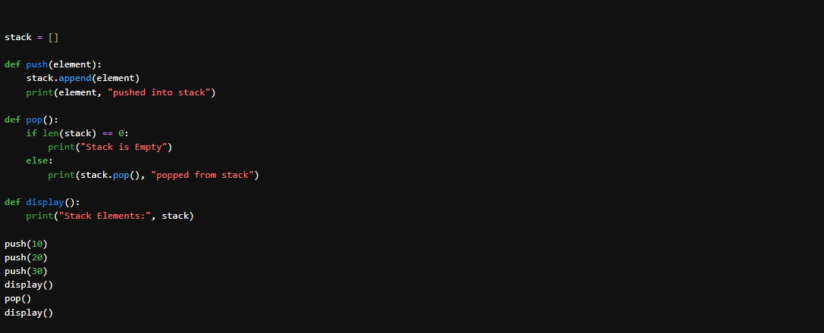
OP | 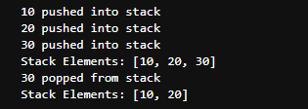
2 | Program for Queue Operations Insert, update, delete, display
SCRIPT | 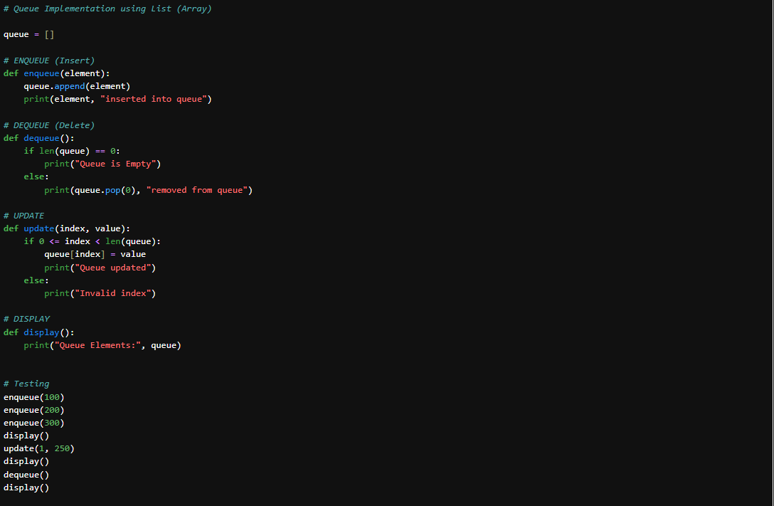
OP | 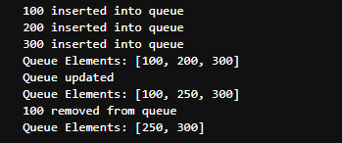
3 | Program to implement both Stack & Queue in same code
SCRIPT | 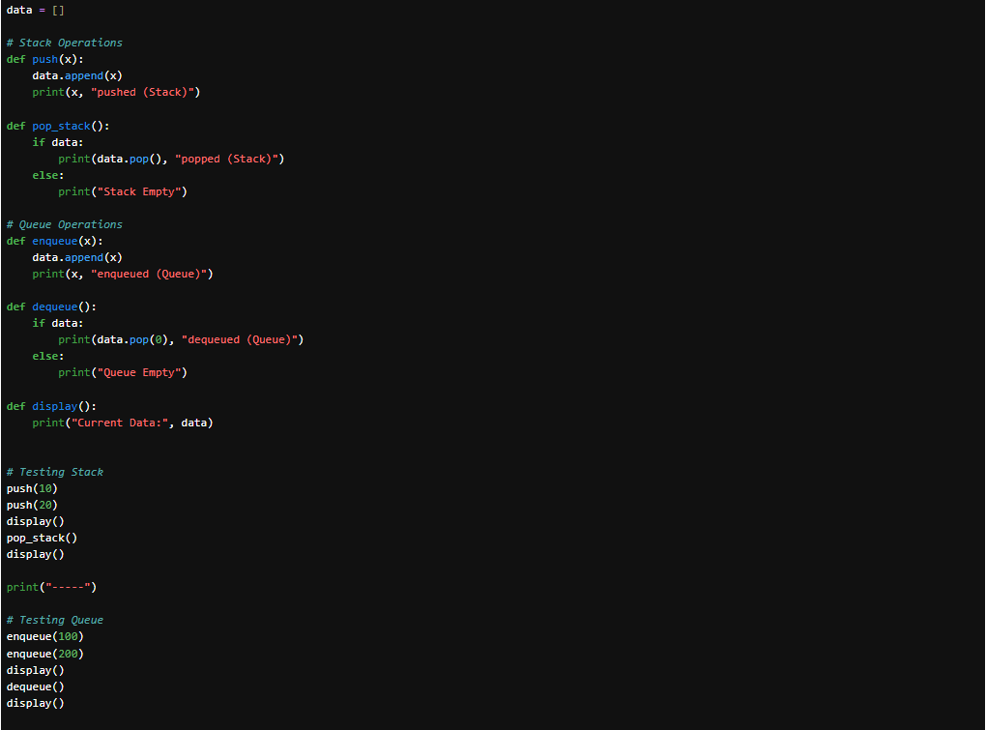
OP | 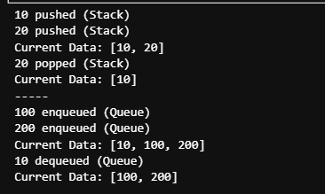
Debugging Questions with Corrected Answers
1 | Debug the following code  Wrong code:  stack = []  stack.pop(2)
OP | Error: IndexError: pop from empty list  Correct code: stack = [10, 20, 30]  stack.pop(2)  print(stack)
2 | Debug the following code  Wrong code:  queue = [1,2,3]  queue.pop()  print(queue)
OP | Error: pop() removes last element → behaves like Stack, not Queue.  Correct code: queue = [1,2,3]  queue.pop(0) # Removes first element (FIFO)  print(queue)
Conclusion | In this experiment, we successfully:  ✔ Implemented Stack using list (LIFO principle)  ✔ Implemented Queue using list (FIFO principle)  ✔ Combined Stack and Queue in single program  ✔ Debugged common errors in Stack and Queue operations  Thus, we understood array-based implementation of linear data structures in Python.
Performance Indicators |  | Teachers Dated and Signature
Process Related  (15 M) | Product Related  (10 M) | Total (25 M)

